Changes to hma-pwl-production-v3.1.1
AC %
- Added a STOP PRODUCTION notification for two consecutive VMA test results below action limits to follow STSP 460-050 460.2.8.2.1.7(3).
- Fixed a bug where VMA flags were flagging VMA’s as exceeding the acceptance limit (> -1.0 from JMF) or the action limit (> -0.5 from JMF) when the VMA was exactly at the respective limit.
- Fixed a bug where %AC notifications would not flag two consecutive %AC test results below the action limits if one test was below the action limit and the next test was below the acceptance limit (or vice versa).

Additional Guidance for Enabling Macros in Microsoft Excel
As of February 23, 2023, Microsoft has blocked macros by default from spreadsheets downloaded from the internet (aka Pantry) to provide additional protection from malicious macros. When this occurs, you will see an error like this at the top of the spreadsheet:
When this error is presented, you will be unable to enable macros using old methods where you could simply click the button in the banner to enable macros. Additional steps are required to enable the macros. Please perform the following steps to enable macros:
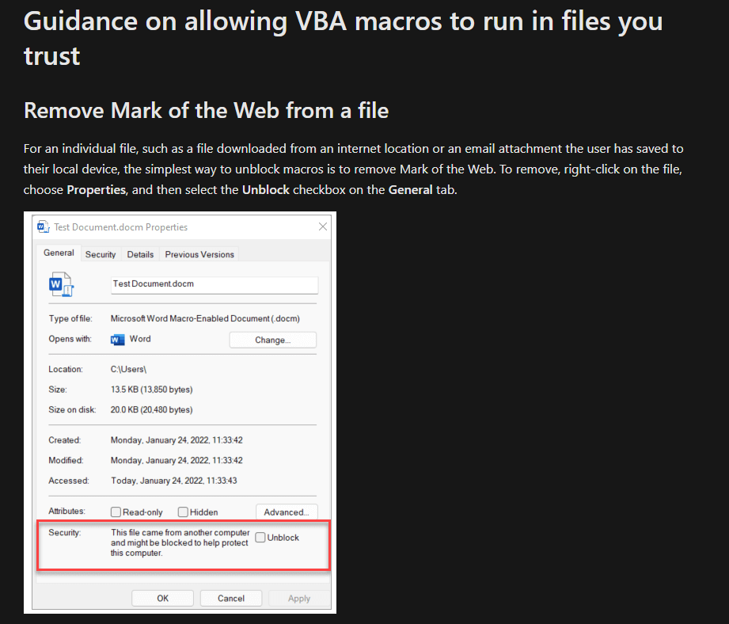

Additional information about this change can be found on Microsoft’s website at:
https://learn.microsoft.com/en-us/deployoffice/security/internet-macros-blocked
If you have any additional questions or issues running macros in your worksheets, please reach out to:
albert.kilger@dot.wi.gov

Changes to hma-pwl-production-v3.1
General
- Coring features have been merged into this release. You will now be able to manage both nuclear and core density for a project using only one worksheet. When you select the density method (Project Info & Instructions, cell C25), the corresponding worksheets will be revealed. Density worksheets will NOT appear until you select a density method.
  - Mainline nuclear and core density are summarized separately in the Total Pay Adjustment Summary. Longitudinal Joint Density for nuclear and core methods are shown as a combined summary in the Total Pay Adjustment Summary.
- Optimizations and fixes for saving/PDF macros.
Project Info & Instructions
- Added Density Method field. Options include Nuclear, Core, and Nuclear & Core. Corresponding worksheets will reveal once a density method is selected. Use the dropdown menu to select the method.
- Added data entry instructions to the following fields: Density Method, Stations-Start, Stations-End.
Core Density Analysis
- Fixed a bug where overflow sublot tonnage was not included in the total lot tonnage.
- Applied a mitigation to the calculation of the PWL factor to account for inaccurate artifact decimals that arise from using IEEE-754 double-precision floating-point representation in Excel.
Nuc Density Pay Factors
- Fixed a bug where Density PWL Pay Adjustments (column AG) wouldn’t calculate if only 1 QC test was entered in the third sublot of a lot.
- Applied a mitigation to the calculation of the PWL factors to account for inaccurate artifact decimals that arise from using IEEE-754 double-precision floating-point representation in Excel.
Gmm F&t
- New notification system for dispute resolution. Notifications will appear below the lot in which they refer.
- Va Pay Factors greater than or equal to 102% no longer override F&t comparison results to yes (with red text).
Gmb F&t
- New notification system for dispute resolution. Notifications will appear below the lot in which they refer.
- Va Pay Factors greater than or equal to 102% no longer override F&t comparison results to yes (with red text).
AC %
- Added Gsb column. Previously, the calculated VMA only used the JMF Gsb; now the most recent Gsb can be recorded for an exact calculation of VMA. Note: The Gsb will auto populate when an AC% test is entered for the sublot. This value can be overridden anytime when the Gsb has changed. All future Gsbs will auto populate based on the previous sublot’s newly entered Gsb (for convenience), until the value is again overridden with a newer value. All previously entered Gsbs will retain their values.
- Corrected VMA action/acceptance limits in hidden cells from -0.2 and -0.5 (±0.2 and ±0.5 for No. 6 mixes), respectively, to -0.5 and -1.0 (±0.5 and ±1.0 for No. 6 mixes) respectively. These values only impacted the drawn limits on the VMA volumetric charts.
- Corrected notification verbiage for VMA limits (Warning Limit -> Action Limit, JMF Limit -> Acceptance Limit) to match the verbiage used in the STSP.
- Expanded the notification area to 3x row height so notifications that are long can be viewed completely without workaround methods.
- Fixed a bug where some QV and BTS cells would only overwrite the existing value if clicked into as opposed to allowing the user to edit the existing value in the cell.
- Fixed a bug where consecutive non-conforming AC contents were not properly tripping the “STOP PRODUCTION…” notification.
- Simplified notification system to only alert when dispute resolution testing is required (removed notifications for calculated AC and Gse tolerances).
- Added min and max VMA specs above the additional volumetric parameters section. Max VMA will only appear when a No. 6 mix gradation is selected on the Project Info & Instruction sheet.
- Changed notification for non-conforming/performing QC AC. It now says to take a non-random QV test according to STSP 460-050 460.2.8.2.1.7(4), Instead of saying to perform BTS dispute resolution testing.
Volumetrics Pay Factors
- Applied a mitigation to the calculation of the PWL factors to account for inaccurate artifact decimals that arise from using IEEE-754 double-precision floating-point representation in Excel.
Data Volumetrics
- Corrected several standard deviations to report the sample standard deviation instead of the population standard deviation. This only affected statistics, not pay.
Data Density
- Added Average Pay Factor (Nuclear and Dispute) which determines the true project pay factor for nuclear density testing. Previously, this did not account for dispute core pay factors.
- Corrected several standard deviations to report the sample standard deviation instead of the population standard deviation. This only affected statistics, not pay.
Va Pay Factor_Comparison
- In order to properly support Gmm/Gmb notifications, the tables have been duplicated. The first tables determine if the initial QC/QV data has a pay factor > 102%. The second set of tables determines if the secondary QC/BTS data has a pay factor > 102%.

